Name Gurkirtan singh
GitHub (https://github.com/gurkirtanbabri/tutedude-devops)
Creating and Renaming Files/Directories
1. mkdir test_dir (to create test_dir Directory)
2. cd test_dir/ (to go inside test_dir)
3. touch example.txt (create an empty example.txt file)
4. mv example.txt renamed_example.txt (to rename example.txt to renamed_example.txt )
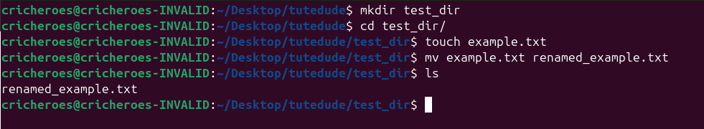
Viewing File Contents
- sudo cat /etc/passwd (to view passwd file need to use sudo because its protected in my system)

2. sudo head /etc/passwd -n5 (to view top 5 line need to use sudo because its protected in my system)
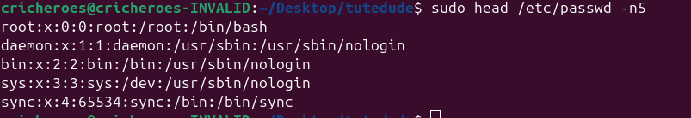
2. sudo tail /etc/passwd -n5 (to view top 5 line need to use sudo because its protected in my system)
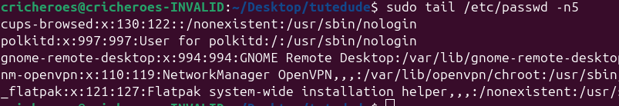
3. Searching for Patterns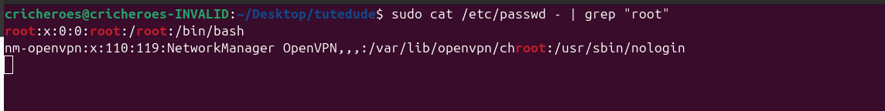
- sudo cat /etc/passwd - | grep "root" ( cat /etc/passwd read the file and | give output of cat to prep and grep search root from than input)

4. Zipping and Unzipping
- zip -r test_dir.zip test_dir (user - for recursive te_dir.zip is filename of zip and test_dir is directory)
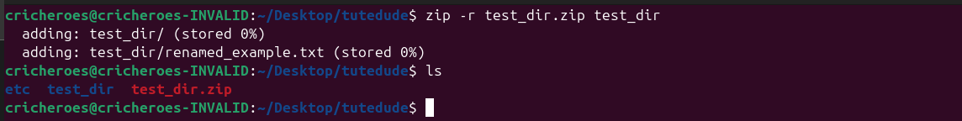
5. Downloading Files
- wget https://example.com/sample.txt (wget [url] )

6 Changing Permissions
- chmod 444 renamed_example.txt (use 444 than mean it is read only for all users)
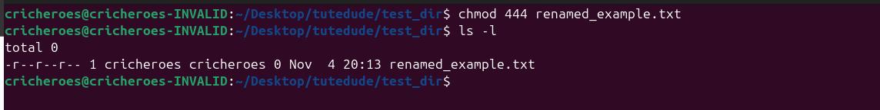
7. Working with Environment Variables
- export MY_VAR="Hello Linux!" (set Env variable)
2. echo $MY_VAR (to print it )
